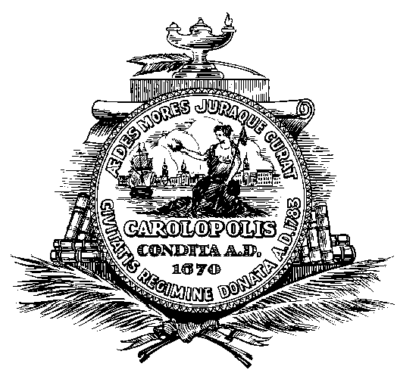
John Tecklenburg  Mayor | City of Charleston  South Carolina | Jacob Lindsey  Director
Department of Planning, Preservation and Sustainability

Notice of Special Meeting

A special meeting of the Short Term Rental Task force will be held beginning at 3:00 PM, July 25th, 2017 at 75 Calhoun St, Public Meeting Room, Third Floor. The agenda will be as follows:

Agenda
- Discussion and work time regarding eligibility of properties for Short-Term Rental.

In accordance with the Americans with Disabilities Act, people who need alternative formats, ASL (American Sign Language) Interpretation or other accommodation please contact Janet Schumacher at (843) 577-1389 or email to schumacherj@charleston-sc.gov three business days prior to the meeting.

