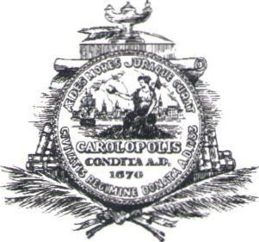
Hotel Task Force Meeting
4:00 PM Tuesday, October 15, 2019
City Council Chambers, Second Floor, 80 Broad Street

AGENDA

- Introduction
- Review of proposed Rooftop Bar Ordinance
- Public Input
- Conclusion

In accordance with the Americans with Disabilities Act, people who need alternative formats, ASL (American Sign Language) Interpretation or other accommodation please contact Janet Schumacher at (843) 577-1389 or email to schumacherj@charleston-sc.gov three business days prior to the meeting.

