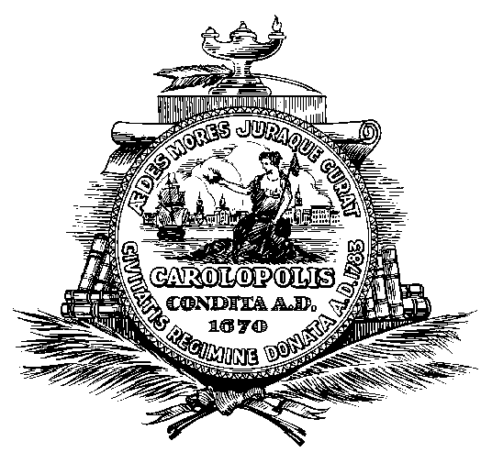
CITY OF CHARLESTON
COMMISSION ON WOMEN
Conference Call #: 1-929-205-6099
Access Code: 81608238263
February 24,, 2025
4:00 p.m.

AGENDA

- Call to Order

- Approval of Minutes:

December 18,, 2024

- Discussion

- Adjourn

In accordance with the Americans with Disabilities Act, people who need alternative formats, ASL (American Sign Language) Interpretation or other accommodation please contact Janet Schumacher at (843) 577-1389 or email to schumacherj@charleston-sc.gov three business days prior to the meeting.

