M&WBE February Spotlight:

Atlantic South
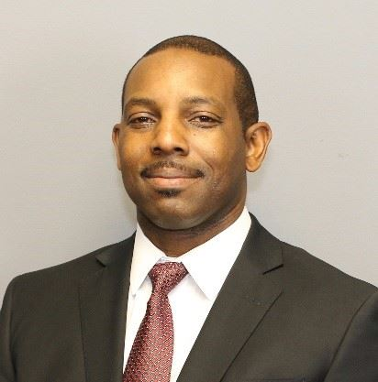

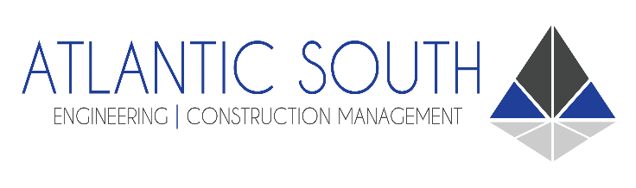

"Atlantic South is a multi-disciplined, full-service private civil engineering and construction management firm. We are committed to providing comprehensive services to meet your needs from inception to completion. We deliver quality solutions to a diverse group of private and public clients, offering expert, dependable, and cost-effective results. Over the last 15 years, Atlantic South has adapted to growing A/E/C industry. We continue to evolve and expand, to keep up with the demanding industry trends. Our talented and professional employees represent more than 75 years of combined engineering and construction experience. Having such a wealth of practical and professional experience in the A/E/C industry, our expertise lies in all aspects of infrastructure design, site development, construction inspection, utility coordination, construction management, schedule control, and quality assurance and control. Atlantic South is SBA 8(a) certified and DBE certified."
-- Adrian Williams – Owner/President
awilliams@atlantic-south.com
843-580-9010
3660 W. Montague Ave. North Charleston, SC 29418

