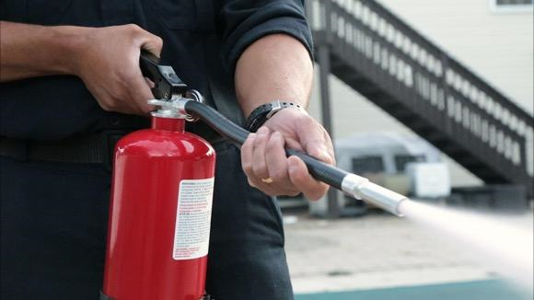
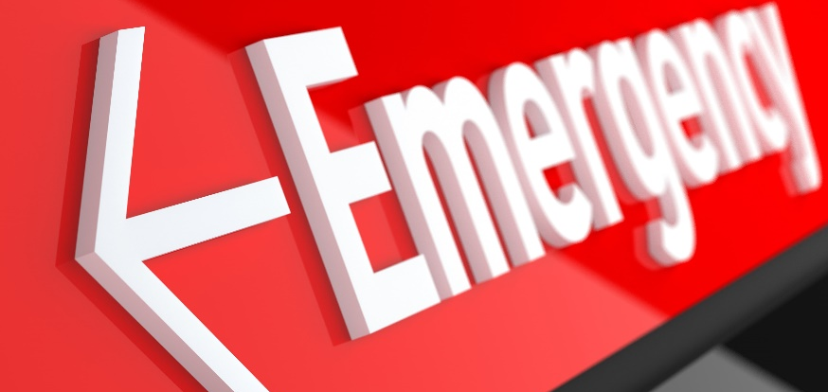
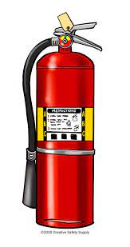
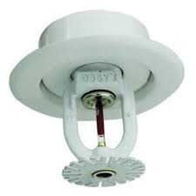
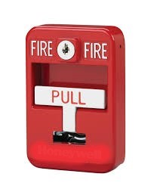
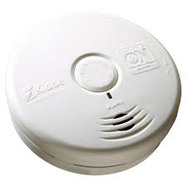
[Facility Name]
[Facility Address]
Version: [Date]

[Insert a photo of your facility]

Fire Emergency Guide
for Multi-Family Residential Buildings
[Note to Management: Work through the document and update all sections that are highlighted, remove non-applicable items, and add specific plans or procedures based on your facility]
Please read and acknowledge the additional fire safety features that are present in your apartment condominium building. Should you have any questions and/or concerns please contact your onsite management team.
Fire Protection features inside your apartment.
- Function of smoke alarms in individual units. These smoke alarms are to alert you when smoke is present in your unit.
  - The smoke alarms are interconnected so when one smoke alarm activates all the smoke alarms in your unit sound.
  - The smoke alarms in your unit are stand-alone smoke alarms where only the alarm closest to the origin of smoke will sound.
    - When the smoke alarms are activated, they will sound three times, pause and repeat until the smoke has dissipated.
    - Do not remove the batteries from the smoke alarms in the event of nuisance alarms occurring. Please contact the property owner or manager to report the problem in writing.
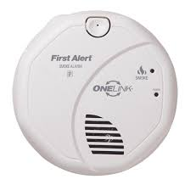
  - Carbon Monoxide Alarm(s) are installed in your unit to detect the lethal, colorless, odorless gas.
    - When the carbon monoxide alarm(s) activate, they will sound four times, pause and repeat until the carbon monoxide has dissipated.
    - The carbon monoxide alarm(s) may be integrated with the smoke alarms installed in your unit.
The responsibility and care of smoke alarms are outlined in South Carolina State Law, 5-25-1330. Management shall provide a signed affidavit to the Fire Marshal Division on a yearly basis showing the testing and battery replacement of the smoke alarms.
Fire Protection and Life Safety feature for the apartment building.
- Fire Alarm Systems:
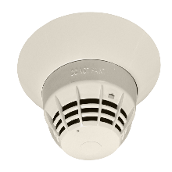
  - Smoke detectors are connected to the building fire alarm system.
    - Smoke detectors are provided within the unit and are connected to the building fire alarm system. If a detector activates, the building fire alarm system will activate and the fire department will be notified and will respond accordingly.
      - If you burn food, please consider keeping your unit door closed, open a window or door to the exterior to ventilate the smoke to prevent unwanted fire alarm activation.
    - Smoke detectors are provided in the common spaces of your apartment building, i.e. corridors, lobby, etc. If a detector activates, the building fire alarm system will activate and the fire department will be notified and will respond accordingly.

  - Red manual fire alarm pull stations:
    - The red manual fire alarm pull stations are located at common space exit doors to the exterior or at the entrance to the stairwells. Activating a manual fire alarm pull station will activate the building fire alarm system.
      - Upon activation of the manual fire alarm pull station the fire department will be notified and will respond accordingly.
      - Upon activation of the manual fire alarm pull station a phone call to 911 is required, as the system does not report to the fire department.
  - Fire Sprinkler System:
    - The building is equipped with an automatic fire sprinkler system. The fire sprinklers only activate when the temperature at an individual sprinkler head exceeds a temperature well above normal room temperature. If a fire sprinkler head activates, only the sprinkler head closest to the fire activates and NOT every sprinkler in the building.
      - DO NOT HANG ANYTHING FROM THE SPRINKLER HEADS AS THIS MAY CAUSE UNINTENTIONAL ACTIVATION.
  - Building Fire Alarm System Notification
    - The building fire alarm system will alert you to an emergency by sounding a tone from the horns in your unit. The alert will be three loud tones, a pause and then repeated. This sound will be louder and different then the smoke alarms in your unit. When these horns sound, please evacuate the building and assemble at the exterior assembly point designated by ownership/management.
    - The building fire alarm system will alert you to an emergency by sounding a tone from the speakers in your unit. The alert will be three loud tones, a pause, and then a voice message providing instructions what action to take. When these speakers sound, please follow these instructions, evacuate the building, and assemble at the assembly point designated by ownership/management or as directed by the fire alarm system.
    - White strobe lights will activate when the fire alarm system sounds. These strobes will flash three times, pause and repeat. When these strobes activate, please evacuate the building and assemble at the exterior assembly point designated by ownership/management.
- Fire extinguishers:
  - Fire extinguishers are located on each level of the apartment building within a maximum of 75’-0” travel distance.
  - The provided fire extinguishers are designed to handle wood/paper, electrical, or liquid fuel fires. These can be used on a grease fire in your kitchen.
  - To use the fire extinguisher, follow the instructions on the extinguisher or as follows:
    - Pull the pin.
    - Aim the nozzle at the base of the fire from a safe distance.
    - Squeeze the handle
    - Sweep the base of the fire from side to side.
- Elevator Use during a fire event:
  - DO NOT use the elevator when the fire alarm sounds or during a fire event.
  - DO NOT attempt to use the elevator to access the ground floor during a power outage.
- Stairwells with two way emergency communication systems
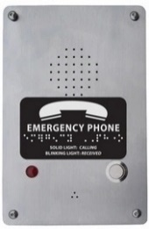
  - In the event of a fire alarm activation or during a fire event, proceed to the closest stairwell.
  - If the fire event is on your floor, press the two-way communication button. This will place you in contact with either a qualified person on site at the building entry, a 911 operator, or a central station. Please speak clearly and loudly to indicate the address and floor where you are located. This information will be relayed to fire personnel who will assist you in exiting the building.
- Open-flame cooking devices (Management please revise to include requirements in your lease that may extend beyond those listed in the code)
  - Charcoal burners and other open-flame cooking devices shall be not operated on combustible balconies or within 10 feet of combustible construction.
  - Charcoal burners are permitted where buildings, balconies and decks re protection by an automatic sprinkler system.
  - LP-gas cooking devices having LP-gas container with a water capacity not greater than 2-1/2 pounds are permitted.
  - Use of charcoal and/or LP-gas cooking devices are prohibited on the property.
  - Charcoal and LP-gas cooking devices are permitted to be stored on unsprinklered combustible decks and balconies if cold to the touch and empty of charcoal ashes.
  - Charcoal and/or LP-gas cooking devices are prohibited from being stored on decks and balconies on the property.
- Open burning, Recreational Fires and Portable Fireplaces (Management please revise to include requirements in your lease that may extend beyond those listed in the code)
  - The use of portable outdoor fire pits, fireplaces, and/or fire pans is not permitted unless located 50’-0” from any structure, and provisions shall be made to prevent the fire from spreading to within 50 feet of any structure.
  - Open burning, Recreational Fires and Portable Fireplaces are prohibited on the property.

