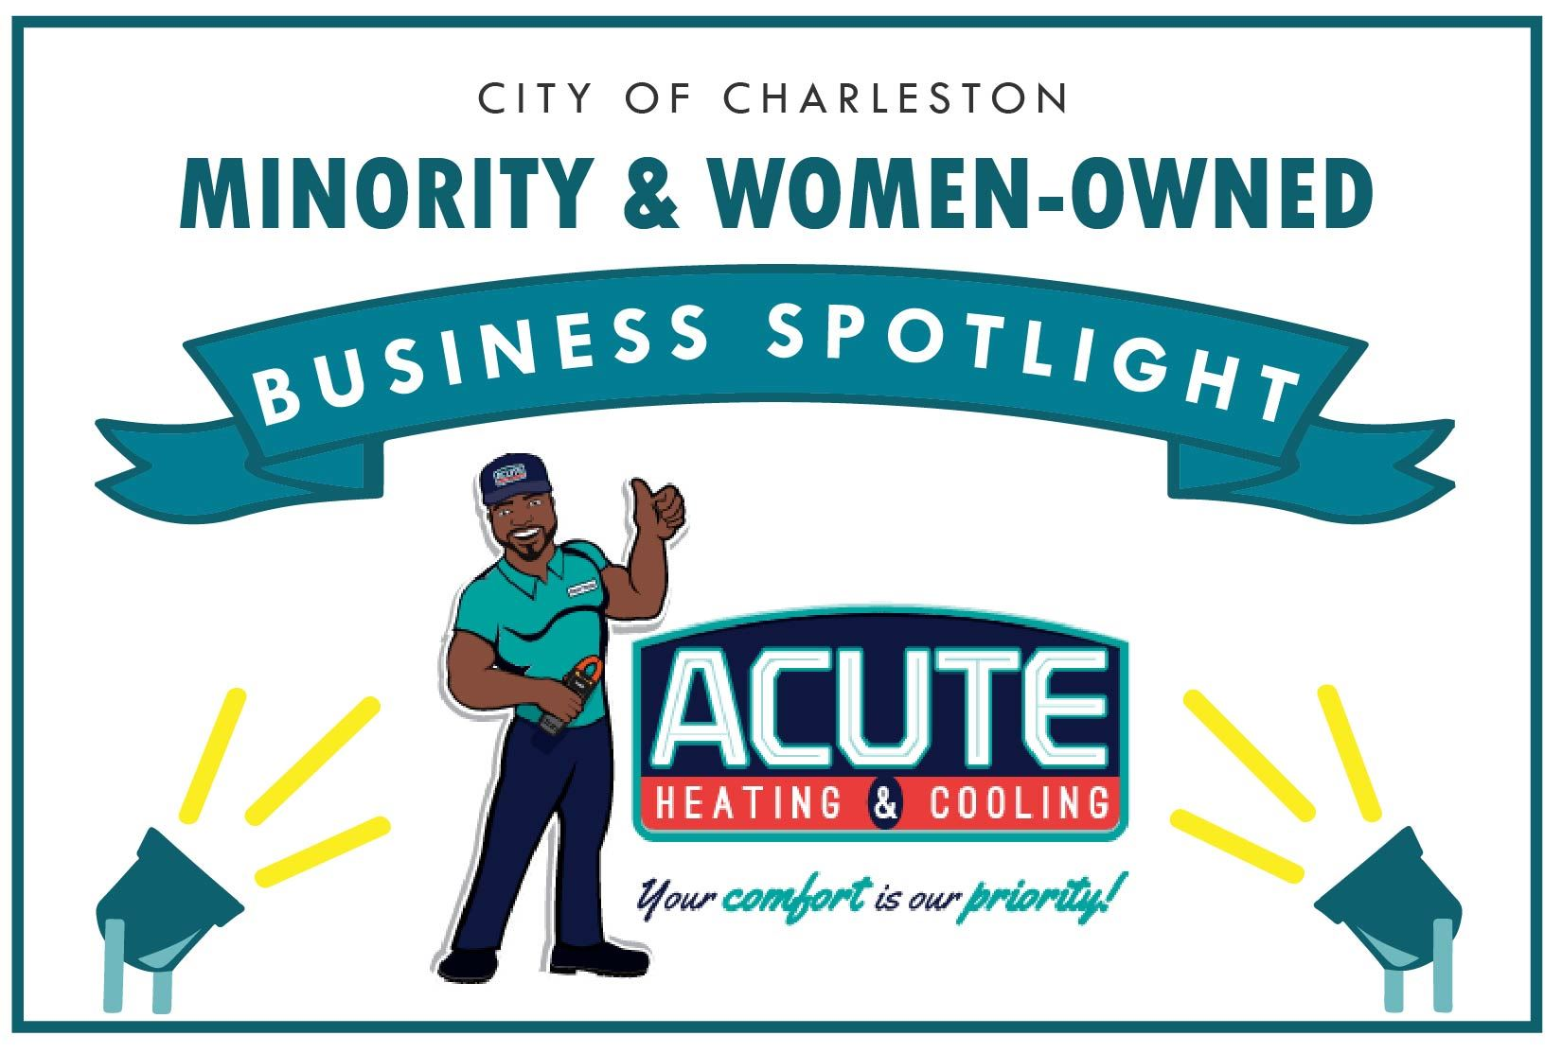


Acute Heating & Cooling

Owners: Thomas & Octavia Edwards
Email Address: comfort@acutehvac.com
Address: 1235 Boone Hill Rd, Suite 1 Summerville SC 29483
Phone: 843-899-2665
Website: acutehvac.com
How long have you been in business? 5 years, 9 months
Number of employees: 10

Please give us a brief description of the business:
Acute Heating & Cooling is a full-service HVAC company dedicated to providing our clients with exceptional service.

What is your business philosophy/mission statement?
At Acute Heating and Cooling, our mission is to build long-term relationships with our residential and commercial clients. We do this by providing highly qualified professionals who give accurate, honest information that assists our clients with making informed and sound decisions, keeping either their families or workplace safe and comfortable. We strive for 100% customer satisfaction on each and every visit: your comfort is our priority.
What we believe: Our greatest asset, and the key to our success, is our team. We believe that each of us needs a sense of dignity, pride, and satisfaction in what we do. Because satisfying our clients depends on the united efforts of many, we are most effective when we work together cooperatively, respecting each other’s contribution and importance.
How we behave: We demonstrate our beliefs most meaningfully in the way we treat each other and by the example we set for one another. In all our interactions with our clients, team, and people in general we seek to deal with others as we would have them deal with us.

Why does this business deserve to be a M&WBE Spotlight Business?
Acute Heating & Cooling is owned by a dynamic husband and wife duo. The reason we believe that we deserve to be an M&WBE Spotlight Business is because of our inspirational story. We have overcome so many obstacles as business owners, but in spite of those obstacles through grit, determination, and our commitment to each other as partners we have become successful. We are dedicated to inspiring others to pursue their goals while overcoming their obstacles. Most importantly we accept the responsibility of leading others, especially our team. We are committed to giving back and being highly involved in our community. Ultimately, we believe that our story can empower business owners in general specifically business owners who are a minority and/or women-owned small businesses because they can easily relate to our story and be inspired by it, especially husbands and wives who operate a business together.
Our Story:
Meet Thomas and Octavia Edwards! This dynamic husband and wife duo works hard to balance business and family life while raising four bold and beautiful daughters. They truly have a testimony of how hard work and determination can bring success to a business endeavor. With a humble beginning, Thomas – a licensed HVAC mechanical contractor, started Acute Heating & Cooling as a one-man operation. Because he set his standards of quality and customer service high, while maintaining an upright character, integrity, and technical know-how, he earned the title of “Honest Thomas,” a sterling reputation. But don’t be mistaken! Octavia may not come and install your air conditioning unit- but her contributions to the company have aided in its success. Octavia, who is also an entrepreneur, keeps things running smoothly behind the scenes. Her excellent business management abilities, combined with his knowledge and skill make for one power couple! Largely by word-of-mouth referrals, the company quickly grew into a successful business. Because of Thomas and Octavia’s steadfast dedication, Acute Heating & Cooling continues to flourish today!

Growth: How has this business grown since its establishment (in employees or revenue)? What is the vision and potential for growth in the future?
Due to our quality of service, our business has experienced substantial growth. With a humble beginning, Thomas – a licensed HVAC mechanical contractor, started Acute Heating & Cooling as a one-man operation, and shortly after I (Octavia) came on board and we became power partners and accelerated the growth of Acute Acute Heating & Cooling. Presently we are a team of 10 and next year because of our projected growth we will be a team of 14. Last year we hit just over 1-Million in revenue and we are tracking 1.7 Million for 2022. It has definitely been a humbling and gratifying experience. Our vision for the future is to continually maintain our healthy reputation within our community while expanding more into commercial and adding more services to our portfolio. Ultimately providing more career opportunities to those who desire to move up within our team and others who would like to join our team.

What activities does your business engage in to support the broader community? For example: hiring veterans, charity work, volunteerism, etc.
We are very active in our community. We hire veterans and participate in the veterans retraining program. We offer internships to those who would like to pursue an HVAC career and we are in partnership with Trident Technical College and a non-profit organization that works with the youth who are considered high-risk or underprivileged. In addition, we engage in youth programs by volunteering our time in youth K12 programs such as Career Day, Entrepreneurship Programs, mentorship, leading Black History Month presentations, and awarding scholarships to seniors who are pursuing higher education. We also give back to our community by making charitable donations to non-profit organizations that are making a positive impact in our community.

What sets your business apart from competitors?
In addition to our mission and core values, what sets Acute Heating & Cooling apart from our competitors is our Honest Thomas Approved Guarantee which is the same values of the high level of workmanship, professionalism, dependability, accountability with a focus on customer service that we were founded on and continue to uphold. Our clients also love that we offer flat rate upfront pricing, and absolutely no pressure sales, just honest and professional advice.

What's one valuable lesson you've learned that you would share with other business owners?
One of the most valuable lessons Thomas and I have learned as business owners and would like to share with other business owners is the importance to take the time necessary to learn different aspects of your business that you need to know, such as understanding your financials in order to understand the health of your business and to plan better for the future so you can be prepared for unforeseen temporary setbacks that can hinder your business's overall health. In addition establish your BAIL relationships (Bank, Accountant, Insurance, and Lawyer), so if you are ever in a pickle you have a team that you have built a relationship with and they will be able to readily assist when you are in a time of need. In business, ignorance is not bliss, what you are ignorant of will cost you money. Building relationships are important and necessary.

Tell us an interesting and fun fact about your business:
Our mascot "Honest Thomas" is in the likeness and image of my husband Thomas Edwards.

