M&WBE Spotlight Nomination Form

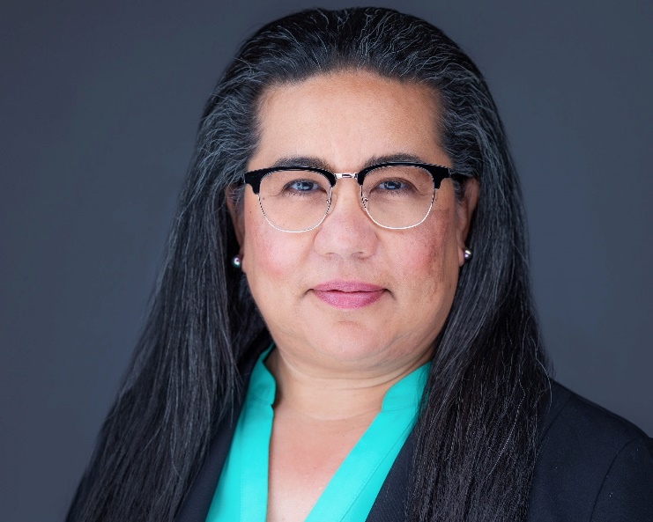

Owner: Trischia Khouri
Address: 170 Meeting Street Suite 110, Charleston, 29401
Website: https://khouri.group/
Phone: 843.400.3009
How long have you been in business?: 3 years
Number of employees: 1-5
Please give us a brief description of the business:
We advise government agencies and corporations on which emerging technologies are worth embracing to solve organizational challenges. Our services include top-tier consulting and training on the ABCs (Artificial Intelligence, Blockchain, and Cybersecurity).
What is your business philosophy/mission statement?
We recognize the challenges businesses face when implementing new technologies. Trust, cultivated over time, is the foundation of our approach.
Why does this business deserve to be a M&WBE Spotlight Business?
KhouriGroup, a proud local enterprise passionately champions the cause of sustainable education in critical fields like artificial intelligence, blockchain, and cybersecurity. Our commitment to these domains is not just about technology -it’s about fueling sustainable economic growth for the future.
Growth: How has this business grown since its establishment (in employees or revenue)? What is the vision and potential for growth in the future?
Through our unwavering dedication to sustainable education in pivotal sectors like artificial intelligence, blockchain, and cybersecurity, KhouriGroup is not only advancing technological frontiers but is dedicated to solidifying our position as a leading women-owned local enterprise. Our vision is to increase our employees and revenue through strategic initiatives that cast a wide net to support our community and thrive collectively.

What activities does your business engage in to support the broader community?
We offer webinars on the fundamentals of emerging technologies, featuring experts who share their insights and mastery in these domains.
What's one valuable lesson you've learned that you would share with other business owners?
Never abandon your aspirations. Stay anchored to your fundamental beliefs; they are your guiding light.
Tell us an interesting & fun fact about your business:
Many assume we're in the hospitality sector due to our pineapple logo. Interestingly, their guess isn't entirely off the mark. And I love Pineapples, too.

